SCOUT
Functional Specification Document

Ver # | Date | Author | Reviewer | Comments
1.0 | 05/16/2014 | Fan Yu |  | Initial Document
1.1 | 06/30/2016 | Abhay Pachbhai |  | Added skip soft stop functionality and new basic and manual exceptions under Audit queue
1.2 | 11/08/2016 | Edwin Guru Singh |  | Added section 3.5 & 3.6 for the story release (#172977, #174380, #179502)
1.3 | 11/24/2016 | Edwin Guru Singh |  | Updated section 3.6 for #190562,Added section 4.2 for #154898
1.4 | 12/07/2016 | Edwin Guru Singh |  | Added section 3.7 & 3.8 for #174890
1.5 | 12/14/2016 | Edwin Guru Singh |  | Added section 3.9 for #196785
1.6 | 01/24/2017 | Faiz Khan |  | Updated section 4.2 for #201526
1.7 | 01/26/2017 | Edwin Guru Singh |  | Updated section 3.10 for #197695
1.8 | 03/16/2017 | Edwin Guru Singh |  | Updated section 3.11 & 3.12 for #208695,#214497
1.9 | 04/11/2017 | Faiz Khan |  | Updated section 4.2 for #218289
1.10 | 04/19/2017 | Edwin Guru Singh |  | Updated section 4.2 for #220697
1.11 | 06/08/2017 | Edwin Guru Singh |  | Added section 3.13 for #225952 & 4.3 for #228775
1.12 | 09/15/2017 | Edwin Guru Singh |  | Updated section 4.2 for #242691
1.13 | 10/26/2017 | Edwin Guru Singh |  | Updated section 3.9 for #247256, 4.3 for #219980
1.14 | 11/15/2017 | Edwin Guru Singh |  | Added section 3.14 for #250147

Table of Contents
Contents
1 Introduction 4
1.1 Overview 4
1.2 Purpose 4
2 Functional requirement 4
2.1 Process 4
2.1.1 Workflow Genesis 4
2.1.2 UI Audit 5
2.1.3 Workflow Retest 7
2.1.4 Referral 7
2.1.5 Workflow Terminate 7
2.2 Architecture 7
2.2.1 Work Queues 7
2.2.2 Technologies 8
2.2.3 SSIS 8
2.2.4 Web services 8
2.2.5 Workflows 9
2.2.1 UI (ASP.NET) 10
2.3 Implementation 11
2.3.1 Solutions 11
2.3.2 CARD Workflow 11
2.3.3 CARD Tool All Projects 16
2.3.4 CARD Automation 18
3 Some exceptions of Workflow 18
3.1 CARHAFA 18
3.2 FBCSFT-LTRREQD 20
3.3 CARLTR IL 21
3.4 New Basic and Manual Exceptions under Audit Queue 22
3.5 CARSFT-LTR : 22
3.5.1 Applied the target logic only for the below letter codes. When the target conditions are satisfied, then this Soft Stop exception (CARSFT-LTR) will be caught by respective workflow process 22
3.5.2 Added the following new letter codes & its respective logic. If the below logic are satisfied, then this Soft Stop exception (CARSFT-LTR) will be caught by respective workflow process(Main,Retest) for the respective AuditTypes (PreFc,FBC). 22
3.6 CARDOC-MD : 24
3.7 Current Logic of CARHAMP : 25
3.8 Current Logic of CARHAFA : 26
3.9 Close bunch of exceptions at a time by Administration: 27
3.10 Disabled the exception : CARHRD-JRPVMAN 28
3.11 Disabled the exception : CARHRD-BRE and CARHRD-WDR 28
3.12 New Note Type “QC Note” added 28
3.13 Disabled the exception : CARHRD-INSC 29
3.14 Disabled the exception : CARSFT-LMD 29
4 extension for scout 29
4.1 Automatically assign SSIS package 29
4.2 Appended the new logic to SSIS package(“ForeclosureReferral.dtsx”) 30
4.3 Appended the new logic to SSIS population & termination package 31
5 GLOSSARY 31

FUNCTIONAL SPECIFICATIONS

Introduction

Overview
SCOUT is a tool that is used to create, manage, and work audits on loans that being considered for foreclosure. An audit will be created for all loans that are in a specified state, or meet specified requirements, for foreclosure in the SPS system. Currently there are two audit processes that SCOUT will manage, pre-foreclosure and forbearance closeout. SCOUT is oriented around a daily batch process.

Purpose
SCOUT uses many technologies to help the Default Administration department audit loans for the foreclosure process. Some of the projects that are used in this tool are intended to be used as core API assemblies in an enterprise architecture system for SPS. With some refactoring, unit testing, and architecting that goal can be accomplished.

Functional requirement

Process
Basically SCOUT is consisted of three parts: SSIS, Card Workflow, Card Audit Tool.
Every day SSIS imports loans to AuditLoan table then workflow audit these new loans. User can check which loan has which exceptions through Card Audit Tool to do further process.

Workflow Genesis
Everyday a population of loans that meet specified requirements is collected into a batch of loans that need an audit. Once the loan population has been determined the process of auditing the loans is started using a Workflow that represents the individual audit. The Workflow audits have three stages; hard stop exceptions, soft stop exceptions, basic exceptions and the Workflow is the controller of the audit through these stages. The Workflow will first determine if there are any hard stop exceptions that exist. If there are hard stop exception conditions the Workflow will create work items for each exception that a condition is met and then go to sleep and wait for the auditor to resolve the hard exceptions through the UI. Once the auditor has resolved all the hard exceptions for the loan the Workflow will be woken up from the UI by the auditor and the Workflow will proceed with the audit. Soft stop exceptions are the next stage for the Workflow audit. Soft stop exceptions are exceptions that can be system resolved, for example; a waiting period on a letter. If there are soft stop exception conditions for the loan being audited the Workflow will create a work item for each exception that a condition is met and then go to sleep for a day and wake up each day to see if the soft stop exceptions have been resolved by the system. If all the soft stop exceptions are resolved then the Workflow completes the soft stop work items and proceeds with the basic exception stage of the audit. Basic exceptions are the final stage of the Workflow audit. All basic exception conditions are found and a work item is created for each exception. Once the basic exception stage is complete the audit is now completed with the Workflow portion of the audit and ready for an auditor to interact through the UI to find resolutions to the exceptions and move the loan audit through the UI audit process to pending referral stage.

UI Audit
Once the Workflow has moved through the three stages to find exceptions and create work items for each exception the control of the audit will be turned over to the auditor. The auditor will use the SCOUT UI to resolve work item exceptions and move the audit through the auditing process to the pending referral queue. Once a loan is in the pending referral queue control of the audit is handed to the referral process. Hard stop exceptions are also cleared by the auditor using the UI.

For Pre-FC and FB audit type under soft stop queue for “Skip Soft Stops” functionality is available for loans in “Soft Stop In-Progress” status only. For loans in Soft Stop Queue with open exceptions checkbox is visible for an auditor to skip the multiple individual exceptions. If auditor checks any open exceptions and click the skip soft stop button popup window with Note text area and checked exceptions is shown to skip the exceptions. All checked exceptions of a loan are cleared by Workflow. If auditor does not check any open exceptions and click the skip soft stop button popup window with Note text area open shown to skip the soft stop queue audit for that loan. For Pre-FC and FB audit type under Soft Stop Queue for loan status “Soft Stop Completed” and there are still some open soft stop exceptions available Reason is shown for the latest open exception if there are no any open soft stop exceptions then Reason is shown as blank. For Pre-Fc and FB audit type under “Pending Referral” queue for loans status “Referral Pending” Reason is shown if the loan has multiple reasons then those reasons are concatenated with semi colon, if no reasons then Reason is shown as blank.

Some of the “Referral Pending” reasons are like below:
- CARD Pending Review
- Credit in Rec Corp
- Lts Process stop is K/Z/A
- Msp Process stop is K/Z/A
- Sr Lien in FC
- Sr Lien info not updated

Snapshot: Skip Soft Stops

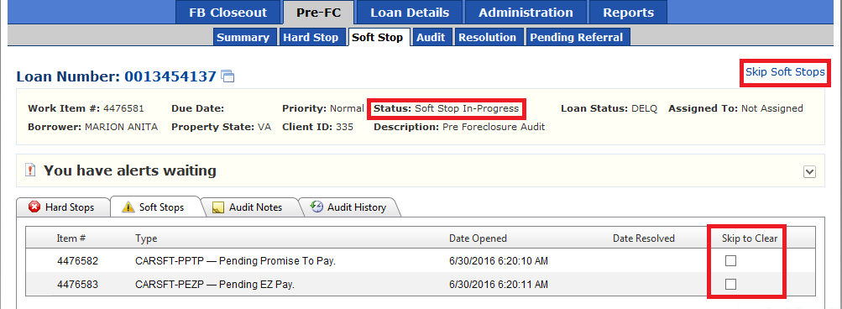

Snapshot: Soft Stop Completed loan displaying Reason

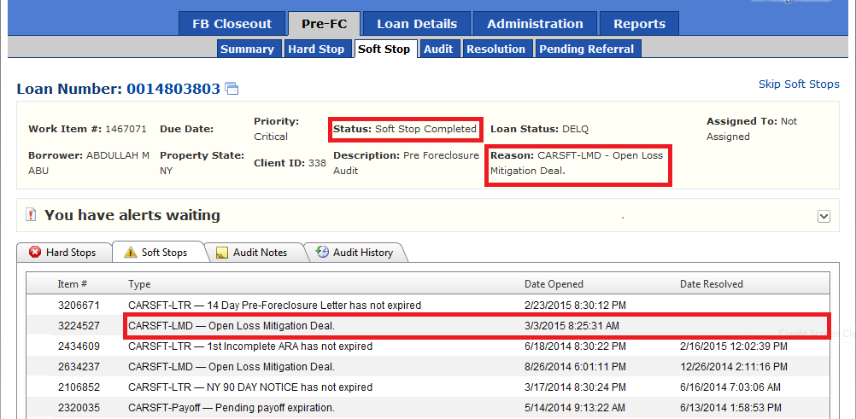

Snapshot: Referral Pending loan displaying Reason

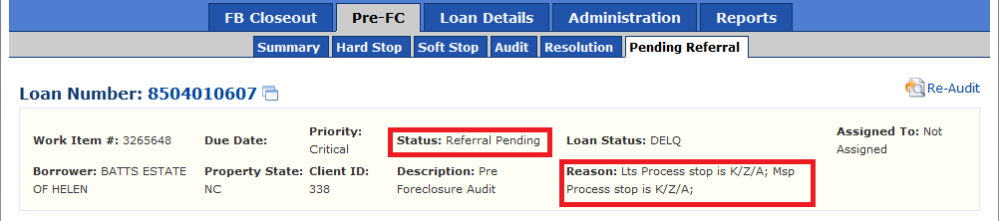

Workflow Retest
Audits that are pending referral will go through one more Workflow audit that is a retest audit. There are two retest audit processes in SCOUT, pre-foreclosure retest and forbearance closeout retest. Retest Workflow audits have the same three stages as the main audits; hard stop exceptions, soft stop exceptions, and basic exceptions, and they have the same mechanisms for waking up a Workflow and proceeding with an audit as the genesis audits do.

Referral
Once the main audit and the retest audit are completed a referral process runs that will refer the loan to foreclosure process and the audit is considered completed and out of the SCOUT environment.

Workflow Terminate
In process audits can have a loan state change or requirements met that make the loan no longer qualified for the foreclosure process. A cancel process determines these situations and cancels the audits for all the loans that no longer need an audit.

Architecture

Work Queues
Work queues are defined in the SCOUT system to represent channels of work. Each queue represents a state of the audit where the work item that represents the audit will be placed. Depending on which work queue the work item is in will determine what work on the audit will need to be done. Example; if the work item that represents the audit is in the pre-foreclosure hard stop queue, then an auditor that works the pre-foreclosure hard stop queue will use the UI to clear the hard stop exceptions and a callback is made to the Workflow to continue the audit. Queues are the underlying architecture for control of the work item that represents the audit.

Technologies
SCOUT uses a number of different technologies orchestrated to manage the individual audits, tool administration and reporting. These technologies include SSIS, Web services, Workflows 4.0, ASP.NET, and the Entity Framework.

SSIS
The three processes that are handled by the SSIS packages are the load/initiate, retest, and terminate. Each audit type (pre-foreclosure, forbearance closeout) has a specific load/initiate, retest, and terminate package for a total of six SSIS packages that are used by SCOUT. The load/initiate package contains logic for determining the loan population for the audit type, inserts a new audit for each loan in the population, and then makes a Web service call to initiate the audits. Retest package makes a Web service call that will initiate the retest audit process. Terminate package contains logic for determining which loans (that are currently being audited) need to have the audit terminated because of loan state change, sets a bit on the audit record to indicate cancelled, and then makes a Web service call to initiate the termination of the audits.

Web services
SSIS has the capability to talk to Web services. For this reason a Web service layer exists for the SSIS packages to interface with. Each Web service contains logic for interacting with Workflows, the Workflow Control Endpoints for each Workflow, and business logic that relates to entities in the database that the SCOUT system uses.

Workflow Genesis is a Web service that contains the logic for starting the pre-foreclosure and forbearance closeout audits. Once the SSIS package for load/initiate has loaded the new audits into the database it will make a call to this Web service and to the method that is associated with the type of audit that is being initiated. The web method will get the request and look for the population of audits for that type that need to be started. Once the population is determined a request to start the audit will be made to the related Workflow that contains the logic for the audit.

Workflow Retest is a Web service that contains the logic for retesting audits before the loan is referred to foreclosure. The retest SSIS package will make a request to this service and call the retest method that is associated with the audit type. A population of audits that need to be retested will be collected by the method and a request for each audit will be made to the retest Workflow that is associated with the audit type.

Workflow Terminate is a Web service that contains the logic for terminating audits. The terminate SSIS package will run and determine which loans can be removed from the audit process based on state changes. A bit on the record that represents the audit will be set to indicate that the audit is to be cancelled. Once the terminate population has been determined and the bit set by the SSIS package, the package will make a request to the web method on this service that cancels audits. First the service will cancel the audit at the audit tracking level. Next it will cancel the work items that are associated with the audit. Last it will make calls to the Workflow Control Endpoint of the audit that is being cancelled to terminate the Workflow instance.

Exceptions can happen during the execution of a Workflow. This puts the Workflow into a suspended state. The Web service contains logic to find Workflows that are in a suspended state to attempt to get the Workflow into an unsuspended state using the Workflow Control Endpoint for the specified audit.

Workflows
Each audit begins with a Workflow that contains business logic for finding exceptions and creating work items for each exception found that an auditor will have to clear during the audit process. There is a Workflow defined for each audit type, pre-foreclosure and forbearance closeout. A retest Workflow for each audit type is also defined. Three main audit sections are defined in the Workflows; hard stop exceptions, soft stop exceptions and basic exceptions.

When exceptions are found in the hard stop section the Workflow will create the work item for each hard stop exception found and then the Workflow will be persisted (“goes to sleep”) to wait for a callback from the UI. Once the auditor has completed the hard exception work items, a callback is made from the UI to the Workflow to “wake up” the Workflow instance up and proceed with the rest of the audit.

Soft stop exceptions are exceptions that can be cured by the system. If soft stop exceptions are found a work item is created for each exception found. Then the Workflow will go to sleep for configured time, usually a day, then wake up and check the soft stop exceptions to see if the condition still exists for the work item. If the condition is still true the Workflow will go to sleep for another day and check again. This will continue until there are no soft stop exceptions found in the audit. Once the soft stop conditions are all met the audit will continue to the basic exception section of the Workflow. In UI if an auditor marked some soft exceptions of a loan to skip, Workflow will clear those marked exceptions for Pre-FC and FB audit type in both Main and Retest Workflow.

The last stage of the Workflow audit is the basic exceptions. If basic exceptions are found a work item is created for each exception. Once this section is complete the Workflow that represents the audit is now complete and the audit is now ready for an auditor to work using the UI.

Workflow states are tracked by a tracking participant. This participant keeps track of events that the Workflow can generate while executing. The states that are tracked are; aborted, canceled, suspended, terminated, unhandled exception, and unsuspended. Each event tracked will be stored in the database for reporting in the UI. A suspended/unsuspended tracking participant also exists to handle Workflows that go into a suspended or unsuspended state.

UI (ASP.NET)
SCOUT has a UI that is used by auditors, administrators, and the development team to work the audits and manage the system. The UI is an ASP.NET web application. Tabs are used to organize the different functions and queues of the SCOUT tool. There is a main menu tab for each audit type, loan details, administration and reports.
Pre-foreclosure and forbearance closeout audits each have a main menu tab that, when clicked, shows a sub menu of tabs that represents the work queues that contain the audits that are being worked by auditors or waiting for referral. Example; under the pre-foreclosure tab there is a sub menu of tabs that has a tab for hard stop, soft stop, audit, resolution, and pending referral queues. An auditor that is working one of these queues will go to this tab to get the next audit that needs to have exceptions cleared to finish the audit of the loan. The summary tab is the only tab that does not represent a queue, but represents a summary of the audits for that type. Searching for an audit by loan number is also on this tab. Requesting an audit of the audit type that is selected can be done on this page.

Loan Details is a tab for doing a search on a loan and getting detailed information about the loan. Loan information, balance information and property information for the loan can be view here. Also, payments, historical information, audit log, and ACM data about the loan is accessed through this page. Payment information includes; payments, advances, disbursements, and fees. Historical information includes; contacts, letters, BPO, property inspections, disputes, loss mitigation and the audits on the loan. Audit log contains information on state changes of the loan. The information on this tab is used by an auditor to understand the history of the loan and work the audit.

Administrators use the administration tab to manage the system. The error log for the system is contained in this tab and is used by the development team to gain information on exceptions in the system. Security uses a mix of windows authentication and a security architecture that is based on the global employee table, roles and permissions. An administrator will set up roles for auditors and give access to specific tabs depending on what queue the auditor will be working. This includes setting up the roles and permissions for each report. Work queues are managed on this tab also. Administrators will assign auditors to queues for the auditor to work. Creating a work queue is also done on this tab. Workflow tracking is accessible from this tab also. Tracking is used to audit the state of Workflows that are running. If a Workflow becomes suspended, then an administrator can used the functionality to get the Workflow into an unsuspended state.

Reports can be accessed from the reports tab. Each report has a permission that allows an administrator to restrict access to the report. Reporting services is where the reports live and a report viewer control is used to show the report to the user from the reporting services server.

Hard stop exceptions will make a Workflow go to sleep. An auditor will work the hard stop queue to clear these hard stop exceptions. Once all the exceptions are cleared the UI is responsible for making a callback to the Workflow to wake the Workflow up and continue the audit.

Implementation

Solutions
SCOUT logic is organized into three Visual Studio solutions; CARDWorkflow, CardTool – All Projects, and CARDAutomation. Each solution uses project references to reference projects that contain code that is necessary to build all the code in the solution. Some of the project references are to projects that are considered to be reusable in other architectures. Other projects are CARD specific logic that is only applicable to the SCOUT tool. All third party assemblies are contained in a Dependencies folder in the CardTool – All Projects solution. Each solution that contains the projects that are deployed will have four configuration settings; Debug, Int (integration), Test, and Release. These settings are specific to environments at SPS and transformation configuration files are used to get the correct setting for each environment.

CARD Workflow
The CARDWorkflow solution contains the SCOUT logic related to the Web services and Workflow implementations. The CARDWebServices project represents the Web services deployment. The CARDWorkflows project represents the Workflows deployment. The other projects are a mix of projects that were designed to be reusable and SCOUT specific projects that contain logic specific to the SCOUT system.

CardAudit.Entities project is an entity project. This project contains the entity framework model for the entities that have the DADM_CARD prefix on the tables. Each entity project will have a data access class that wraps the entity context into common CRUD tasks preformed on the entities. Extension method classes for the entities should be contained in this project. Partial classes on the entities are organized here to avoid losing helper methods when the entity framework is regenerated.

CARD Contracts project is where contracts with the rest of the code are defined. This project should never have a reference to any project that isn’t a .NET framework assembly. The reasoning for this constraint is that this project defines classes and interfaces that establish what other projects will depend on as “contracts” or agreements within the framework. This is a great place for all constants, data contracts used in WCF, and interfaces that are common among projects. Having this contract project gives the developer a place to put agreed upon code structures that can be referenced by any project in the architecture and know that all the code is speaking the same language. It reduces the amount of duplicated declared constants, utility files, and duplicated helper methods that are created to try and define contracts between the projects used in the architecture. It also contains the Client Channel Manager class that is intended to be the manager of communication to the WCF interfaces defined for the Workflows. Client Channel Manager is designed to use endpoint configuration and understand how Workflow versioning works to establish a single way of talking to Workflow services. Each Workflow service that we have defined as audits and retesting audits has an interface defined in this project that declares the service methods that are available in the Workflow service. Even though the Workflow service does not directly implement the interface, the interfaces are used by the Client Channel Manager to make the calls to the Workflow service. They represent the contract made to all the client code using the Workflow services that this is how the service methods will look. All the request and response messages are in this project also. It is very important to understand that by defining these messages we control what values are correlated on callbacks and what values are used when requesting an audit. By maintaining the classes and keeping them clean it will keep the interfacing with the Workflow services defined. Using the Message Contract and Message Body Member attributes is how the Workflow services are able to correlate on values for callbacks.

CARD Contracts Tests project is where the unit test framework is used by Client Channel Manger as an entry point to interface with the Workflow services. Although the tests defined in the class use the unit test framework, they are by no means unit tests. These test methods are defined only as a place to interface with the Workflow services for entry point testing. All these solutions could have the unit testing improved and this project is no exception. But the tests defined are very helpful for interacting with the Workflow services and can be very helpful in integration testing the Workflow services.

CARD Custom Activities project is where we define custom CARD Workflow activities that contain CARD specific logic. With Workflows you have the ability to extend classes to implement logic that is represented in the Workflow designer. Example; the Update Audit Loan WorkflowId is a CodeActivity<string> that updates the workflow id from the context of the activity to the AuditLoan record. This activity is available in the Workflow designer to drop onto a Workflow and when executed will update the workflow id. Any logic that is repeated over and over again is a great candidate for a custom activity. This project contains some request/reply patterns for talking between other Workflows that depends on interfaces defined in the CARD Contracts project. They were used when CARD used many Workflow services to define logic and the main audit just controlled the call. So these classes aren’t being used right now, but if Workflow architect starts to include calls to other services these classes are extremely useful.

CARD Tracking project contains logic pertaining to Workflow Foundation tracking. The Workflow host will observe the workflows and capture events during execution of the Workflow instance. These events are handed to our tracking participants by the host. There are two tracking participants in this project. The first is a SQL tracking participant that takes the tracking records and inserts them into the database using an entity framework that is designed around the information that the tracking records provide. Second, there is a tracking participant that is used to handle suspended and unsuspended events. These two participants need to be refactored into a singleton participant that uses reflection of type to establish the provider.

CARD WebServices project contains the web services logic for the SCOUT tool. There are three web services; Workflow Genesis, Workflow Retest, Workflow Terminate. These services have been explained above in this document. There is also a Workflow ServiceEngine class that contains logic for suspended Workflow logic. The logic that is in the methods at the service level needs to be refactored into this service engine. When a Workflow instance becomes suspended action is needed to get the Workflow into an unsuspended state. This logic is contained in the Global.asax. A Timer is used to wake up at configured intervals to check for suspended Workflows and uses a Workflow Control Endpoint to unsuspend the Workflow instance. Because there only needs to be one node attempting to unsuspend the Workflows a configurable value is set to true or false depending on if that is the node that should work on the logic. If more than one node is attempting the logic you can get a lot of extra exceptions that are false positives filling up the log.

CARD Workflows project contains the Workflow services that represent the audits and the retesting audits. Each Workflow service starts with a receive activity that is structured around the interface and message contracts defined in the CARD Contracts class. Custom activities are used to manage the AuditLoan record and the parent WorkItem that represents the work in the work queue. Flowchart activities are used to structure the business logic that looks for exceptions on the loan and creates a WorkItem for every exception it has using a custom activity for creating a WorkItem. Persist activities are strategically placed into the Workflow service to setup a rollback point for any unhandled exceptions that will put the Workflow into a suspended state. Once the Workflow is unsuspended it will continue from the last successful persist activity. Versioning the Workflow services is a very important concept contained in this project. If a Workflow is in a hibernation state (waiting for a hard stop callback or a soft stop condition to clear) and a new version of the Workflow is placed into the system, depending on the changes that were made to the Workflow the hibernating Workflow instances may not be able to be serialized back into the new Workflow version. The folder structure has been set up to reflect the major minor version formatting that is defined in the DADM_CARD.WorkFlowVersion table. When a new Workflow service is created, depending on how dramatic the change is, a new major or minor version of folder should be created with an incremented value and the new Workflow service placed there. Take note that the Workflow version is related to the actual version of the specific workflow, not the release version or database version. This allows for flexible versioning of the Workflow. Once the new Workflow service has been created it needs to be defined in the web.config. A RoutingService service has been activated in the web.config called workflowversionrouting.svc. This service has all the Workflow service endpoints that are available that clients send messages to. This keeps the configuration for client application the same while being able to add new versions and have messages routed to the correct version. When a new version is added the service will have to be defined in the <services> section of the web.config. The new endpoint for the service is defined in the <client> section of the web.config; this is the endpoint that the routing service talks to. A filter needs to be added to the <routing><filters> section that represents the new version. AndFilters are used to combine the version filter with the audit type filter to create a combined filter; Example, filter one is a version 1.0 and filter two is pre-foreclosure filter, those combined will be a 1.0 pre-foreclosure filter. The AndFilter for the new version of the Workflow is then added to the <routing><filterTables> and has the new endpoint declared so the routing service knows where to route the message to. Backup lists are declared to give the system a way of trying the message again if there is a delivery failure. The backup list points to the same endpoint as the original filter and gives the system a cheap message redundancy. Any new version needs to be defined in the DADM_CARD.WorkFlowVersion table. And the current Workflow version for any audit type is defined in the DADM_CARD.Constant table. This will indicate to the code and SSIS packages what the current version of the Workflow service is being used. Tracking profiles are defined in the web.config for the tracking participants in the CARDTracking project. The SCOUT UI tool depends on the Error Tracking profile for reports. Suspend and unsuspend logic is dependent on the Suspended Audit Loan Tracking Profile to define the suspended and unsuspended states so those events are tracked and the logic executes.

DADMBL project contains the logic for the business layer. As usual with applications like this the business logic is a bit crazy and there is a lot of it. The logic for each exception exists in these classes and which class depends on what the exception is asking about. If the exception is about letters then the logic will live in the LetterBL class. Loss mitigation logic is in the LossMitigationBL class, and so on and so on. There is also logic that isn’t related to exceptions. WorkQueueBL class contains logic that is associated with the WorkItem and WorkQueue entities. CardAuditBL class contains logic associated with the AuditLoan, CardRule, WorkflowVersion, and Constant entities. Each class is a static class with static methods. This isn’t necessary, but it is how it was architected. This makes these classes difficult to unit test, but there are integration tests using a unit testing framework in the CARD_Automation solution. Most of these classes have entity structures behind them and these classes are a layer of common logic associated with the entity. The Workflow services for the audits use these classes for handling business logic and the custom activities used in the Workflow services also use these classes to implement business logic. Web services also use these classes for implementation of logic. The controller class in the UI uses these classes to implement some logic. This project is intended to be used by other tools that are built for the Default Administration department.

Enterprise.Entities project contains the entity framework around the LighthouseBase_V entities. These entities are used in business logic classes in the DADMBL project. The EnterpriseDataAccess class contains methods for common CRUD data access using the context for the entities.

ErrorLogging project contains the logic for error handling and the entity framework for the entities that are used in the error handling logic. This project is intended to be reused as a global assembly in the SPS enterprise architecture. A global tool id is used to indicate what tool in the enterprise is logging the exception. This assembly needs to be refactored to include a concept of error levels, Example; information, warning, error, critical. ErrorLoggingDataAccess is a class that contains methods for common CRUD data access using the context for the entities.

LoanServicing.Entities project contains the entity framework around the views in the fbrsql database that relate to loan information. Business logic in the DADMBL project uses information from the fbrsql database to analyze the loan during the audit and depends on these entities to select information about the loan in order to make decisions. All views that represent information about a loan in our system will have an entity object in this project. There is a LoanServicingDataAccess class that contains methods for common CRUD data access using the context for the entities.

LossMitigation.Entities project contains the entity framework around the views in the fbrsql database that relates to the loss mitigation deals. Deals are made by SPS to help lenders keep their loans current and to help investors return a profit on assets. Information that represents these loss mitigation deals have views created around the tables in the fbrsql database. Each of those views is represented in the entity model for this project. A LossMitigationDataAccess class contains methods for common CRUD data access using the context for the entities.

Security Management project contains the logic for security management. This project is intended to be reused as a global assembly in the SPS enterprise architecture. An entity framework model is used to define the entities involved in the security management. A SPS enterprise tool has defined roles and permissions that belong to that tool. Roles are defined by assigning permissions to the role. A user of the tool will be assigned a role and that is how permissions are defined for the user of that tool. The Global_Employee_v entity is a view of the HRAdministration database that holds all the employee information and this view is used to ensure that users of the tool are also active employees of SPS. SecurityManagement class contains methods for authorizing users and CRUD operations on tools, users, roles, permissions, and the relations for each of those entities.

WFTracking.Entities project contains the entity framework around the tracking entities that are used to track the Workflow states and events during execution. The model needs to be refactored to normalize the states that are available from the tracking records. WFTrackingDataAccess class is used to handle inserts of the tracking records.

Workflow Activites project contains custom Workflow activities. This project is intended to be reused as a global assembly in the SPS enterprise architecture where Workflows are used. Custom activities that are built around other global assemblies live in the project. Example; the work queue logic established in the Work Queue Management project is intended to be used in other tools. Creating a WorkItem is a very general activity that relates to the global work queue logic. There is a custom activity, (CreateWorkItem) that handles the logic of creating a WorkItem entity using the classes provided in the Work Queue Management assembly. Any custom Workflow activity that is generic enough to be reused in other tool projects should live in this project.

Work Queue Management project contains logic that applies to the work queue architecture that is used to organize work into work queues using work items. This project is intended to be reused as a global assembly in the SPS enterprise architecture. Work queues represent channels where work is assigned by a manager to an employee to complete. Queues are created to represent the overall process that describes how work will be organized and delegated to employees. The WorkItem entity represents the unit of work that is being worked on. The unit of work can be a letter, loan audit, or any other object that a process is wrapped around. The Work Queue Manager is designed to give access to WorkItem Service and Work Queue Service classes. These classes are designed to handle the business logic and CRUD around the WorkItem and WorkQueue entities.

CARD Tool All Projects
The CARD Tool All Projects contains the SCOUT logic for the ASP.NET UI. Card Tool project represents the UI deployment project. This solution is organized using folders to try and separate projects into related responsibilities. Many of the projects in this solution are also in the CARD Workflow solution.

CARD Automation folder contains projects that are from the CARD Automation solution that are used in the UI logic. Every project in this folder is also contained in the CARD Workflow solution. Please refer to documentation above for a description on these projects

Logging folder contains projects that are related to the error logging. ErrorLogging project has been discussed above. It is the reusable assembly that contains global error handling logic. ErrorLogging.Web project contains an IHttpModule implementation that uses the error logging logic to handle exceptions using the request pipeline provided by IIS and ASP.NET. Error Logging HttpModule has to potential to be refactored into the Error Logging project so that any other ASP.NET sites can implement this module and get error handling out of the box.

Web Application folder contains the deployment project for the UI and third party assemblies that the UI is depended upon to function. The Card Tool project is the deployment project for the ASP.NET UI. This UI is meant to be a template for other SPS tools (tools that implement the security, error logging and work queue logic). A mix of controller pattern, web services, and code behind provide the logic for the UI. Routing is used on most pages that use the controller pattern to handle logic. Code behind contains the logic for pages that are not using the controller pattern. Web services are used to provide information that is requested from the client side of the application. Security is a mix of windows authentication and custom implementation. Windows authentication is the mode that is set in the web.config, once the windows authentication is completed (handled by IIS and AD) then the authenticate event is fired and the Global.asax contains the method that is tied to this event. In this method is where the custom authentication using the Security Management assembly to authenticate the user against the tool users and against the employee table maintained by HR. If a user is successful with the windows authentication, but fails the tool authentication, the user will be asked to register as a user for the tool. An email is sent to the administrator of the tool to approve the user for use. Users, roles, and permissions for the SCOUT tool are managed in the Administration tab. Authorization is handled in the web.config by using location elements to define the permissions needed to access parts of the tool. The Authorization model is incomplete and needs to be enhanced in future revisions. Error handling is applied using an implementation of the IHttpModule interface, ErrorLogginHttpModule. This module uses the Error Management class (the class intended to be used globally) to log exceptions. All exceptions logged for the SCOUT tool can be viewed using the error log tab in the Administration tab. Dependencies folder contains any third party assemblies that are referenced by the CardTool UI project.

Work Queue folder contains the Work Queue Management project that is a global assembly that is intended to be reused in the SPS enterprise. Please refer to the documentation above for details about this project.

CARD Controller project contains the logic for the controller pattern that is used in the routed pages in the UI. This project also contains logic for some of the reports, security implementation, and routing. The intent of this project was to contain all logic that the UI used. That way any UI could be used and get the behavior that is in this project. As the UI is refactored into a controller pattern using routing the logic should be moved into this project to disconnect the logic from the UI project.

The data access layer of Card Audit tool uses entity framework. Currently work item table already has like more than 2 million records besides there are some history tables with more data. So it needs to take care of the performance of loading or searching in Card Audit Tool. For example the detail page now uses partly loading. It doesn’t load all data when being firstly open. The history data only can be loaded when the history tab is clicked. So this can improve some performance for the page loading.

CARD Automation
The CARD Automation solution contains the unit tests for the DADMBL project. This solution was intended to contain only business logic and the tests that are associated with the business logic. Use this solution when adding unit tests or maintaining unit tests for the DADMBL project code. Using Team Server you can find the Visual Studio 2008 solution for the SSIS packages (CARDAutomation\Database\SSIS Package\CARD_Automation). The unit tests in this solution are integration tests, they require the database connections.

Some exceptions of Workflow

CARHAFA
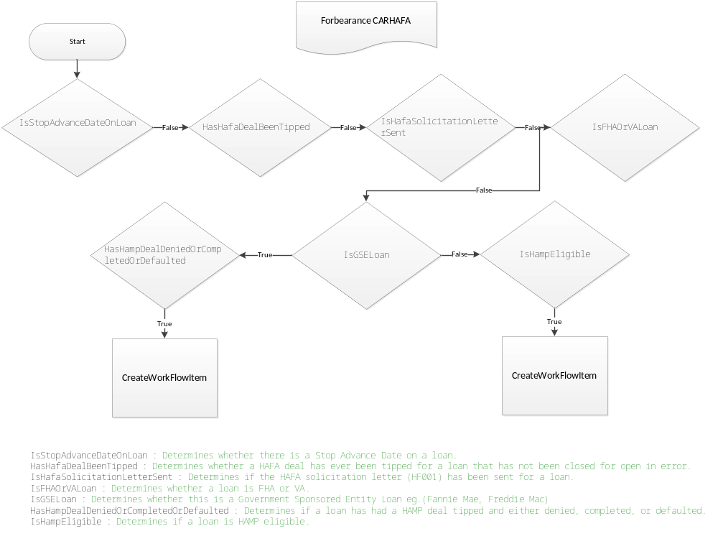
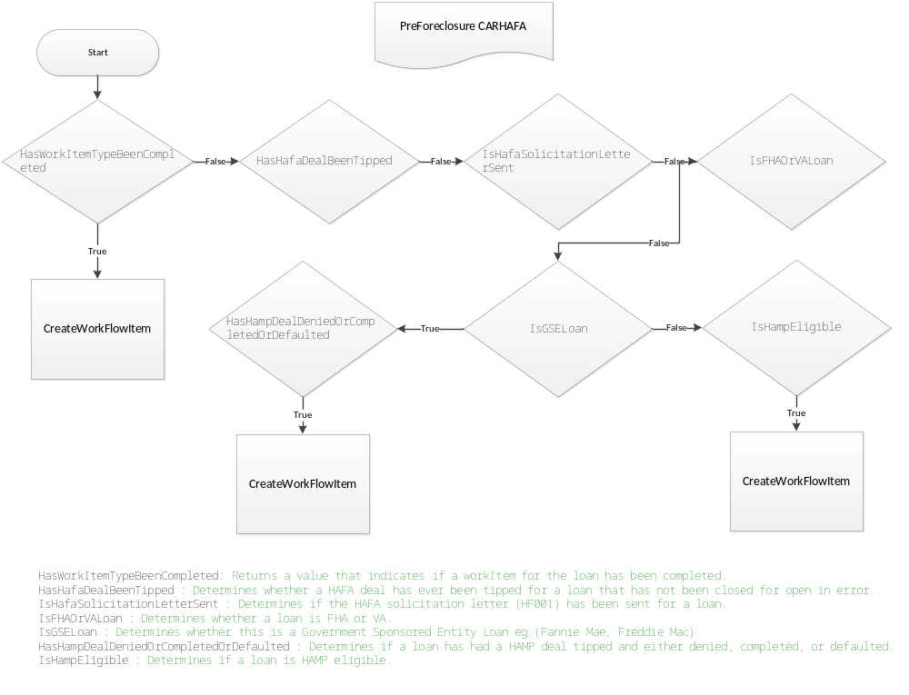

FBCSFT-LTRREQD
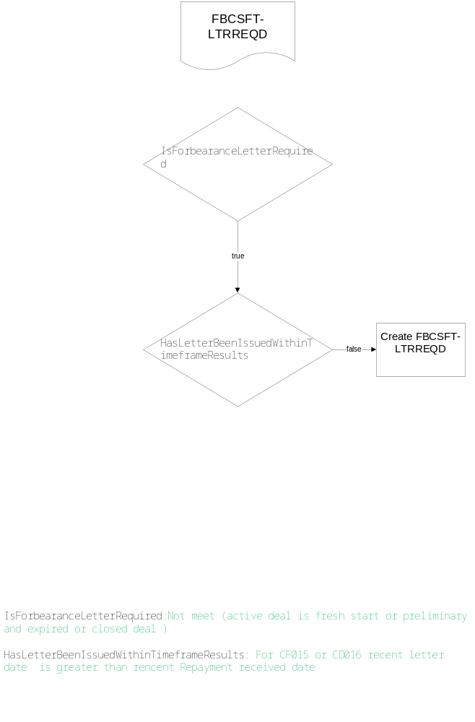

CARLTR IL
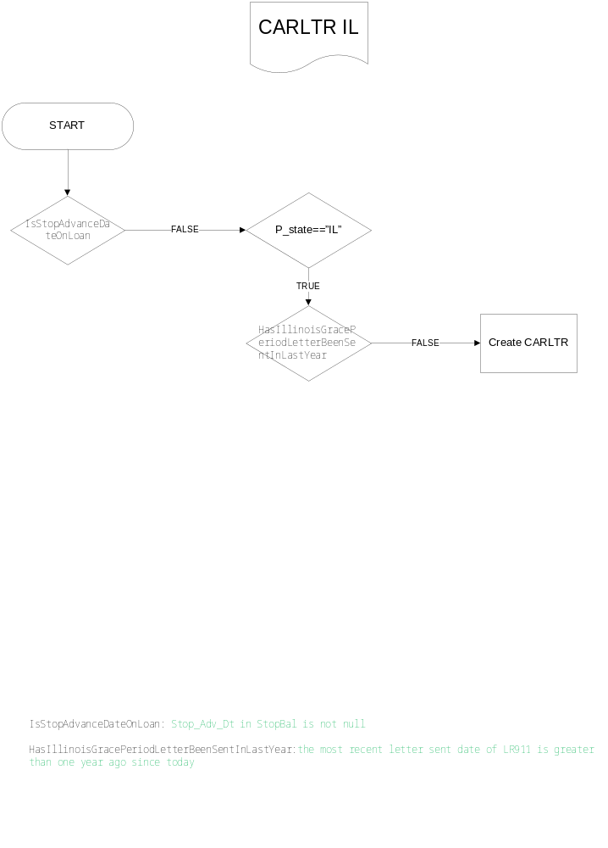

New Basic and Manual Exceptions under Audit Queue
Below six basic exceptions are added in Pre-FC and FB audit type.

Exception Name | Criteria to create exception | Descriptions
IN Pre-Suit | Property State = "IN" | Indiana Pre Suit Notice Required
Hawaii HUD | Property state = 'HI" | Hawaii HUD Notice Required
NY 90 | Property state = 'NY' | NY 90 Day Notice Required
RI Mediation | Property State = "RI' | Rhode Island Mediation Notice Required
CT EMAP | Property State = "CT" | CT EMAP Notice Required
IL Grace | Property sate = "IL | Illinois Grace Notice Required

Below two basic manual exceptions are added only for Pre-FC audit type.

- QC-FAIL
- QC-PASS

CARSFT-LTR :

Applied the target logic only for the below letter codes. When the target conditions are satisfied, then this Soft Stop exception (CARSFT-LTR) will be caught by respective workflow process
Applicable Letter Codes | Existing Logic | Target Logic | Audit Type
Applicable Letter Codes | Existing Logic | Target Logic | PreFC | FBC
AG414,FD005,  CH414,HF001,  HF020,LR924,  LR925,LR926,  LR934,LR935 | [today <expirationDate] | [today <= expirationDate] | Main & Retest WF Process | Main & Retest WF Process

Added the following new letter codes & its respective logic. If the below logic are satisfied, then this Soft Stop exception (CARSFT-LTR) will be caught by respective workflow process(Main,Retest) for the respective AuditTypes (PreFc,FBC).
Letter Code | Letter Name | Logic
CF312 | Customer Opt Out Assumptions | today < letterDate.AddDays(30)
CF020 | Initial Doc Receipt/New Doc Required MIL | dueByDate != null && dueByDate != DateTime.MinValue ? today <= dueByDate : today <= letterDate.AddDays(30)
CF021 | Prior Complete Package Facially Complete MIL
CF022 | Minimum Document Package Received Facially Complete
CF023 | No Due Date MIL | today < letterDate.AddDays(30)
CF500 | Initial incomplete information notice | dueByDate != null && dueByDate != DateTime.MinValue ? today <= dueByDate : today <= letterDate.AddDays(30)
CF510 | Initial document receipt MIL
CF511 | Prior complete package, new information received to require additional documents
CF512 | Received facially complete package
CF513 | No Due Date MIL
CF520 | Conditional approval | Workout Status in ‘Pending’ or ‘Active’  And Workout Options in  ‘HAFA Short Sale Review - Listing Period’ or  ‘SPS Short Sale Review - Listing Period’ or  ‘BAC Short Sale Review - Listing Period’ or  ‘JPM Short Sale Review - Listing Period’ or  ‘HAFA Short Sale Review - No Listing Period’ or  ‘SPS Short Sale Review - No Listing Period’ or  ‘BAC Short Sale Review - No Listing Period’ or  ‘JPM Short Sale Review - No Listing Period’
CF521 | Complete customer document packet | dueByDate != null && dueByDate != DateTime.MinValue ? today <= dueByDate : today <= letterDate.AddDays(30)
CF530 | Approval notice | subtype ‘Short Sale Offer’ exists in the Lossmitigationdeal table AND status in ‘Active’ or’ ‘PENDING’ or ‘Processing’
CF540 | Short Sale Denial | Workout Status in ‘Processing’ or ‘Pending’ or ‘Active’ And Workout Options in ‘HAFA Short Sale Review - Listing Period’ or  ‘SPS Short Sale Review - Listing Period ‘ or  ‘BAC Short Sale Review - Listing Period’ or  ‘JPM Short Sale Review - Listing Period’  -----  Else  -----  Subtype ‘Short Sale Offer’ exists in the Lossmitigationdeal table AND status in ‘Processing’ or ‘Pending’ or ‘Active’
CF550 | Short Sale listing period expiration notice | Workout Status in ‘Pending’ or ‘Active’  And Workout Options in ‘HAFA Short Sale Review - Listing Period’ or ‘SPS Short Sale Review - Listing Period ‘ or ‘BAC Short Sale Review - Listing Period’ or ‘JPM Short Sale Review - Listing Period’
CF560 | Short Sale Offer Expiration notice | IF Subtype ‘Short Sale Offer’ exists in the Lossmitigationdeal table AND status in ‘Processing’ or ‘Pending’ or ‘Active’

CARDOC-MD :
If any one of the below Property State belongs to respective Loan then this Basic exception (CARDOC-MD) will be caught by respective workflow process.

Current Logic | Audit Type
Current Logic | Pre-FC | FBC
If State="PA"  (or)State="WV"  (or)State="NJ"  (or)State="NY"  (or)State="MA"  (or)State="AR"  (or)State="CT"  (or)State="IL"  (or)State="RI"  (or)State="UT"  (or)State=”CO” | Main WF Process | Main WF Process

Current Logic of CARHAMP :
CARHAMP is the basic exception under AuditQueue which is applicable for Main workflow only to the both AuditTypes such as Pre-ForeClosure & Forbearance Closeout. If any one of the below conditions will satisfy then this Basic exception will be caught by workflow.

IsStopAdvanceDateOnLoan

False

HasWorkItemTypeBeenCompleted(LoanNo, "CARHAMP", WorkItemId)

False
True
Catch Exception
DidLoanOriginateBefore20160901(LoanNo)
True

IsHampEligibleBefore09012016(LoanNo)

True

HasHampModificationBeenTipped(Loan_No)

False

IsHampSolicitationLetterSent(LoanNo)

True
False

IsHampEligible(LoanNo)
IsHampSolicitationFollowUpLetterSent(LoanNo)

False
True
True

Catch Exception
Catch Exception

HasHampSolicitationFollowUpLetterBeenSentThreeTimes(LoanNo)

False

IsReasonableEffortMet(Loan_No)

False

Catch Exception

Current Logic of CARHAFA :
CARHAFA is the basic exception under AuditQueue which is applicable for Main workflow only to the both AuditTypes such as Pre-ForeClosure & Forbearance Closeout. If any one of the below conditions will satisfy then this Basic exception will be caught by workflow.

HasWorkItemTypeBeenCompleted(LoanNo, "CARHAFA", WorkItemId)

False
True
Catch Exception
DidLoanOriginateBefore20160901(LoanNo)
True

IsHafaEligibleBefore09012016(LoanNo)

True

HasHafaDealBeenTipped(Loan_No)

False

IsHafaSolicitationLetterSent(LoanNo)

False

IsFHAOrVALoan(LoanNo)

False

IsGSELoan(LoanNo)

False
True

HasHampDealDeniedOrCompletedOrDefaulted (LoanNo)
IsHampEligible(LoanNo)

Catch Exception
True
True

Catch Exception

Close bunch of exceptions at a time by Administration:
New functionality (Close bunch of exceptions) was implemented in Scout application. Administrator only has rights to clear the exceptions through this functionality. This is applicable for the exceptions (HardStop, SoftStop, Basic & Basic Manual) under the Audit Type of both Pre-ForeClosure & Forbearance CloseOut.
Note:
- This functionality is not applicable for SoftStop exception under any Audit Type.
- The respective WorkItemNoteType as “Status Note” by default while clearing bunch of exceptions by Administration
Screenshot: Home page of this functionality under Admin tab
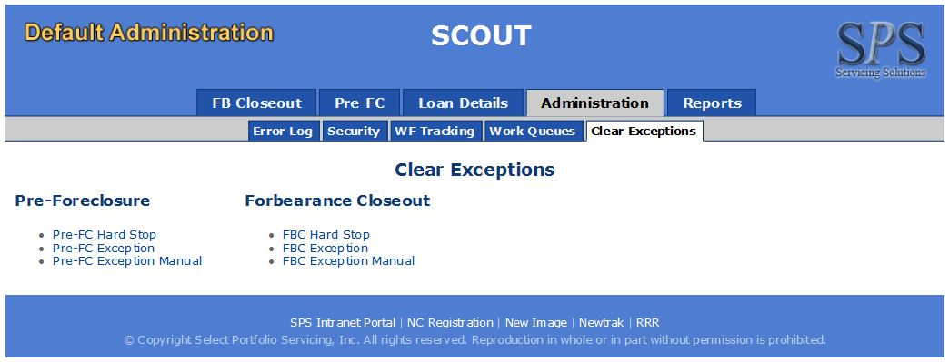
Screenshot: How to clear the multiple exception at a time by Administrator
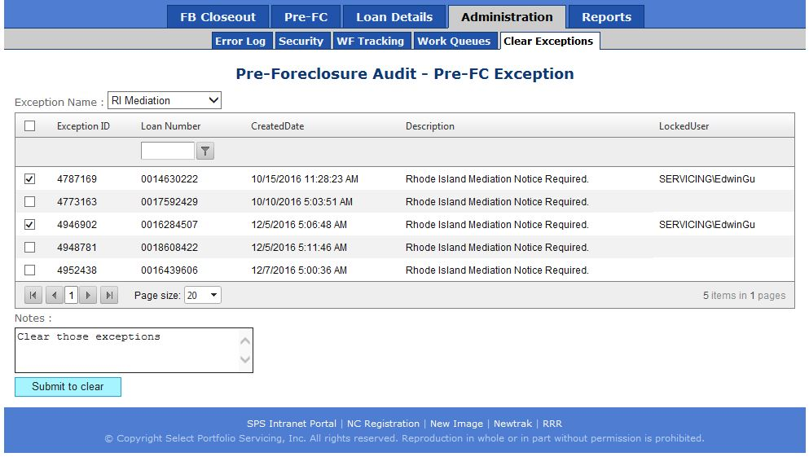

Disabled the exception : CARHRD-JRPVMAN
“CARHRD-JRPVMAN” is a HardStop exception which is applicable for Pre-ForeClosure AuditType with Main Workflow process only. As per recent business’s request, this exception was disabled for upcoming loans which means WF ‘version1.21’ onwards will not catch this exception. Moreover cleared the open exceptions for the existing loans(Old WF versions) through priming script manually.

Disabled the exception : CARHRD-BRE and CARHRD-WDR
“CARHRD-BRE” is a HardStop exception which is applicable for Pre-ForeClosure AuditType with Main Workflow process only.“CARHRD-WDR” is a HardStop exception which is applicable for Pre-ForeClosure AuditType with Main & Retest Workflow process. As per recent business’s request, this exception was disabled for upcoming loans which means WF ‘version1.22’ onwards will not catch this exception. Moreover cleared the open exceptions for the existing loans(Old WF versions) through priming script manually.

New Note Type “QC Note” added
“QC Note” as New Note Type has been added into table “DefaultAdministration.Global.WorkItemNoteType”. This will be applicable for both audit Type(Pre-FC, Forbearance Closeout). This new note type displaying wherever NoteType dopdownlist exists in Scout UI. For Ex : It’s displaying under AuditNotes tab for all workQueues.

Disabled the exception : CARHRD-INSC
“CARHRD-INSC” is a HardStop exception which is applicable for Pre-ForeClosure AuditType with Main & Retest Workflow process. As per recent business’s request, this exception was disabled for upcoming loans which means WF ‘version1.23’ onwards will not catch this exception. Moreover cleared the open exceptions for the existing loans(Old WF versions) through priming script manually.

Disabled the exception : CARSFT-LMD
“CARSFT-LMD” is a SoftStop exception which is applicable for Pre-ForeClosure AuditType with Main & Retest Workflow process and ForbearanceCloseOut AuditType with Retest Workflow process. As per recent business’s request, this exception was disabled for upcoming loans which means WF ‘version1.24’ onwards will not catch this exception. Moreover skipped the open exceptions(IsSkipWF=1) for the existing loans(Old WF versions) through priming script manually & then next day WF cleared those skipped exceptions automatically.

extension for scout

Automatically assign SSIS package
It can automatically assign loans in different work queue to matched user according to a csv file. And finally send email about the result.

Firstly there should be a CardAutoAssignedLoans.csv file in target file path. And the file should include loan_no, req. comments, names columns.
Req: the work queue name in SCOUT.
Comments: comments will be logged when assignment happens.
Names: the user name should be assigned to.

Secondly when the SSIS runs it will loop every row in the file. Then call the stored procedure named [DADM_CARD].[CardAssignLoanToUser] to process each recorded.

At the end of the process of SSIS user will receive a result email about how many loans are successful and how many loans are failed and the reasons caused failed.

There are some variables which should be set before run the SSIS.

Variable Name | Description
SMTPServerName | SMTP server which is used for sending email
TargetFilePath | The location of file used for assignment
ArchiveFilePath | To archive processed file
EmailFrom | Who send the result email
EmailTo | Who get the result email
ServerName | The server which assignment happens on

Appended the new logic to SSIS package(“ForeclosureReferral.dtsx”)
The following new logics are appended with existing logic into the 2012 SSIS package called “ForeclosureReferral.dtsx”
- Part of the process to remove loans with K stops associated with Assumption Mods when letter code is “LR143”
- Added new exception to hold GIBBS & BRUNS loans from referrals on the last two business days of each month.
- Part of the process to update the pvx
  - JPM/Chase loans & client is ‘346’ and (npvreo + fcinterest + reointerest) is less than 10000 →”NPV is less than $10000”
  - JPM/Chase loans & client is ‘346’ and fullBpo_Pvx is less than 10000 →”NPV is less than $10000”
  - BAC loans, client is ‘338’, Occupancy should be ‘unknown’ or ‘occupied’ and (npvreo + fcinterest + reointerest) is less than 3000 →”NPV is less than $3000”
  - BAC loans, client is ‘338’, Occupancy should be ‘unknown’ or ‘occupied’ and fullBpo_Pvx is less than 3000 →”NPV is less than $3000”
  - client is neither ‘346’ nor ‘338’ and the owner type is neither Freddie Mac nor Fannie Mae and (npvreo + fcinterest + reointerest) is less than 7,500 →”NPV is less than $7500”
  - client is neither ‘346’ nor ‘338’ and the owner type is neither Freddie Mac nor Fannie Mae and fullBpo_Pvx is less than 7,500 →”NPV is less than $7500”
  - When the Pre-FC loans holding under Pending Referral queue more than 30 days from created date(Resolution completed to Pending Referral) →”DOD Review Required”
  - All of above logic are appended with existing logic of the Stored procedure called “DefaultAdministration.DADM_CARD.GetPendingReasonForPendingReferral”.This Stored procedure which is used to display the respective holding reason under “Pending Referral” queue in UI when the loan is in ”Referral Pending” status.

Appended the new logic to SSIS population & termination package
The following new logics are appended with existing logic into the SSIS population & termination packages which belongs to Pre-ForeClosure AuditType only.
- Population package “DefaultAdministration_CARD_PreFcAudit_Load.dtsx” :
  - Excluded to importing the HighCost loans when iis MSPBank are R67 & R68
- Termination package “DefaultAdministration_CARD_PreFcAudit_Terminate.dtsx” :
  - Terminated the existing active loans in SCOUT (HighCost loans when its MSPBank are R67 & R68)
- PFB , the new logic
SELECT l.loan_no FROM fbrsql..loan l
INNER JOIN fbrsql..LoanCodes lc ON l.LOAN_NO = lc.loan_no
LEFT JOIN fbrsql..MSPUserFields u ON l.LOAN_NO = u.LoanNumber
INNER JOIN fbrsql..mspbal b ON l.LOAN_NO = b.LOAN_NO AND b.TotalPrin > 0
CROSS JOIN fbrsql..globalvar_lastworkingdate lwd
LEFT JOIN fbrsql..LoanCategoryList a ON a.loan_no = l.loan_no AND a.loancategoryid = '37'
INNER JOIN fbrsql..loancategory c ON c.loancategoryid = a.loancategoryid
WHERE ((b.mspbank = 'R67' AND a.loan_no IS NOT NULL) -- LoanCategoryid 37 is present
OR
(b.mspbank = 'R68' AND (isnull(lc.UCCC,0) = 1 OR isnull(u.TwoPosFld1A,'') = ' 1')))
- Termination package “DefaultAdministration_CARD_FbCloseout_Terminate.dtsx” :
  - Terminate the existing active FB loans in SCOUT when its loanStat not in (‘FB’,’FCFB’)

GLOSSARY
Name | Description
Exception | An work item which meets some kind criteria
HardStop | It has an work item in hard stop queue
SoftStop | It has an work item in soft stop queue

